11 Human Biology **Practice** Reproductive System and Hormonal Control Test

Name: _____________________________ Mark: /93

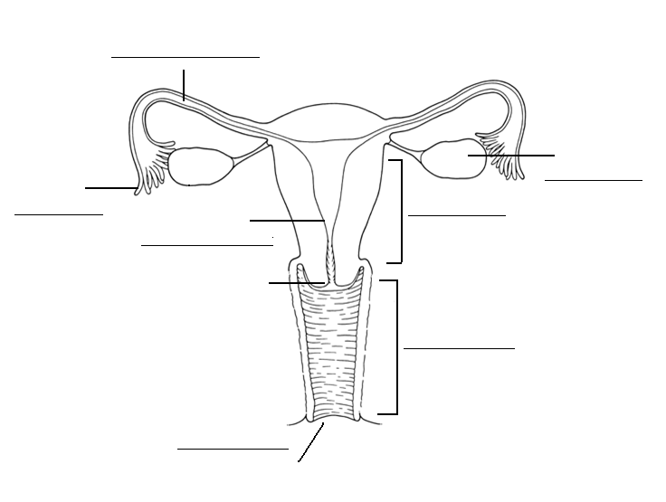1. Label the diagram below. (3 marks)

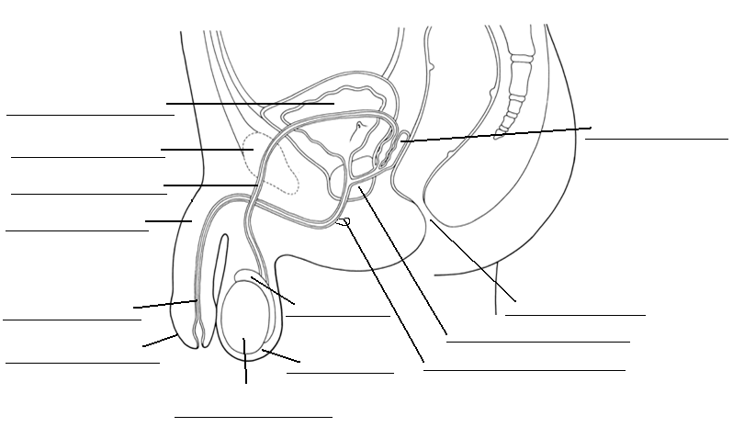

2. Label the diagram below. (6 marks)

3. Fill in the table below. (8 marks)

|  |  |
| --- | --- |
| Structure | Function |
| Ovary |  |
| Fimbriae |  |
| Fallopian tube  (oviduct) |  |
| Uterus |  |
| Vagina |  |
| Testes |  |
| Epididymis |  |
| Urethra |  |

4. Fill in the table below on semen production (8 marks)

|  |  |  |
| --- | --- | --- |
| Organ | Produces | Function of substance |
|  | Sperm |  |
| Seminal vesicle |  |  |
|  | Milky alkaline fluid |  |
|  |  | Acts as lubricant |

5. Fill in the table below. (6 marks)

|  |  |  |  |
| --- | --- | --- | --- |
|  | Number of gametes produced by meiosis | Do hormones cause meiosis to begin? | When does meiosis occur? |
| Oogenesis |  |  |  |
| Spermatogenesis |  |  |  |

6. What are polar bodies? (1 mark)

___________________________________________________________________________________________

7. How do oogonia increase in number? (1 mark)

___________________________________________________________________________________________

8. Where do the spermatids mature? (1 mark)

___________________________________________________________________________________________

9. In what part of the body do embryonic stem cells differentiate into spermatogonia? (1 mark)

_____________________________________________________________________________ ______________

10. Fill in the table of the menstrual cycle. (15 marks)

|  |  |  |
| --- | --- | --- |
| Stage | Days | Events |
|  | 1-4 | ⮚  ⮚ |
|  | 5-12 | ⮚  ⮚ |
|  | 13-15 | ⮚  ⮚ |
|  | 16-20 | ⮚  ⮚ |
|  | 21-28 | ⮚  ⮚ |

12. Using the diagram below, answer the following questions.

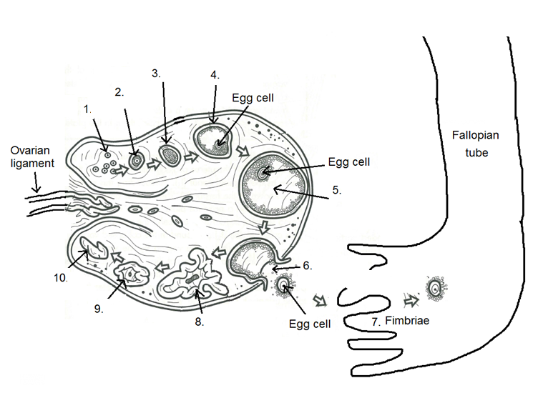

a) What is the name of the structure labelled 2? ______________________________________ (1 mark)

b) What is the name of the structure labelled 3? _______________________________________ (1 mark)

c) What is the name of the structure labelled 5? _________________________________________ (1 mark)

d) What process is occurring at label 6? _____________________________________ (1 mark)

e) What is the name of structure 8? ____________________________________________ (1 mark)

f) What is the name of structure 9? _____________________________________________ (1 mark)

13. List three secondary sexual characteristics that occur in females during puberty. (3 marks)

___________________________________________________________________________________________

___________________________________________________________________________________________

14. List three secondary sexual characteristics that occur in males during puberty. (3 marks)

___________________________________________________________________________________________

___________________________________________________________________________________________

15. What is the layer of follicle cells that surround the mature egg known as? (1 mark)

___________________________________________________________________________________________

|  |  |  |  |  |
| --- | --- | --- | --- | --- |
| Full name of hormone | Where it is secreted from | In male or female? | Target organ | Effect of hormone |
| Follicle Stimulating Hormone |  |  |  | **⮚**  **⮚** |
| Human Chorionic Gonadotropin |  |  |  | **⮚** |
| Luteinising hormone |  |  |  | **⮚**  **⮚** |
| Oestrogen |  |  |  | **⮚**  **⮚** |
| Progesterone |  |  |  | **⮚**  **⮚**  **⮚** |
| Testosterone |  |  |  | **⮚**  **⮚** |

13. Fill in the table below. (30 marks)